# C:\Users\James\AppData\Local\Microsoft\Windows\INetCache\Content.Word\1510864_10152222978819882_1653651865_n.jpg

Software Architecture Design

#### Software Team, James Oatley

# Document Control

|  |  |  |  |  |
| --- | --- | --- | --- | --- |
| Version Number | Modified By | Date | Section(s) Modified | Comments |
| *1.0* | *Unknown* | *Unknown* | *All* | *N/A* |
| *1.1* | *J. Oatley* | *06/04/2014* | *All* | *Re-formatted.* |
|  |  |  |  |  |
|  |  |  |  |  |
|  |  |  |  |  |
|  |  |  |  |  |
|  |  |  |  |  |
|  |  |  |  |  |
|  |  |  |  |  |
|  |  |  |  |  |
|  |  |  |  |  |
|  |  |  |  |  |

Contents

[1 Introduction 1](#_Toc384467469)

[1.1 Heading 2 1](#_Toc384467470)

[1.1.1 Heading 3 1](#_Toc384467471)

# Software Architecture Design

## Design Plan

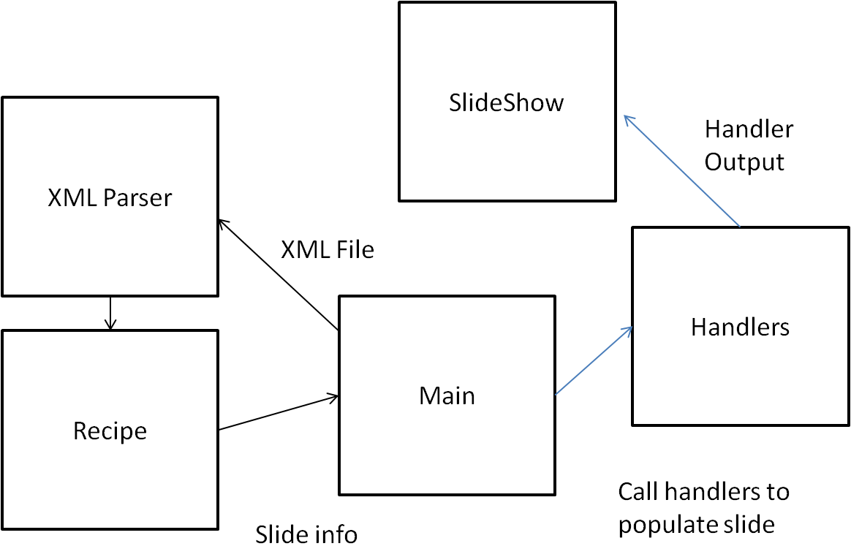

Figure 1.1 – Software architecture inheritance diagram

* XML file is input into the main program
* Main class calls the XML parser class to parse the XML and populate an instance of the Recipe class with the contents of the XML.
* Main class accesses the Recipe class, finds the first instance of a slide within the class, calls the handler classes to populate a slide with text, image, audio, video and graphics.
* This is repeated until all the slides have been created at which point the Main class displays the slide show.